CSS stands with cascading style sheets

CSS extension file name is style.css. we used to represent .css file.

**First line of CSS**:

In html file

<Style>

body{

    background-color: blueviolet;

  }

</style>

Html file we can link css file code as

    <link rel="stylesheet" href="style.css">

This will make your page background blueviolet.

**HTML Refresher**

HTML is a bunch of tags used to lay the structure of a page.

Download HTML notes as part of these notes for a detailed deep dive. If you know basic HTML, continue!

**Chapter 1 : Creating first CSS website**

**What is DOM?**

DOM stands for document object model. When a page is loaded, the browser creates a DOM of the page, which is constructed as a tree of objects.

**HTML id and class attributes**

When an HTML element is given an id, it serves as a unique identifier for that element.

On the other hand, when an HTML element is given a class, it now belongs to that class. More than one element can belong to a single class but every element must have a unique id (if assigned).

We can add multiple classes to an element like this,

<div id = ‘first’ class = ‘C1 C2 C3’> … </div>

Copy

# first is the unique id # C1, C2 and C3 are the multiple classes followed by spaces

**Three ways to add CSS to HTML**

There are 3 ways to add CSS to HTML:

1. Internal <style> tag : Adding <style> … </style> to HTML
2. Inline CSS : Adding CSS using style attribute to every
3. External CSS : Adding a stylesheet(.css) to HTML using <link> tag
4. <!DOCTYPE html>
5. <html lang="en">
6. <head>
7. <meta charset="UTF-8">
8. <meta name="viewport" content="width=device-width, initial-scale=1.0">
9. <title>CSSwebsite</title>
10. <!-- <style>
11. #first{
12. background-color: lightgrey;
13. }
14. .blue-red-green{
15. background-color: lightgreen;
16. color: blue;
17. }
18. </style> -->
19. <link rel="stylesheet" href="style.css">
20. </head>
21. <body>
22. <div id="first" style="background-color: lightpink;">
23. first
24. </div>
25. <div id="second">
26. second
27. </div>
28. <section class="red">
29. red
30. </section>
31. <section class="blue-red-green">
32. blue green red
33. </section>
34. </body>
35. </html>

For external css 3rd type

#first{

    background-color: lightgrey;

}

.blue-red-green{

    background-color: lightgreen;

    color: blue;

}

Detailed example for Internal, Inline, External style sheets

<!DOCTYPE html>

<html lang="en">

<head>

    <meta charset="UTF-8">

    <meta name="viewport" content="width=device-width, initial-scale=1.0">

    <title>Testing HTML</title>

    <!-- External css -->

    <link rel="stylesheet" href="style.css">

</head>

<h1 style="color: brown;">Hello World</h1>

<!-- Inline css -->

<!-- Internal css -->

<style>

    p{

        background-color: blueviolet;

    }

</style>

<body>

    <p>Lorem ipsum, dolor sit amet consectetur adipisicing elit. Cupiditate repudiandae possimus sunt veritatis in nihil.</p>

</body>

</html>

External style sheets are more useful that we can apply that to more than one html files.

CSS Selectors:

A CSS Selector is used to select an HTML element(s) for styling

<style>

        h1{

            color: antiquewhite;

        }

        div{

            background-color: lightsalmon;

        }

    </style>

</head>

<body>

    <div>

        <h1> This is CSS style assignment</h1>

        <p>Lorem ipsum dolor, sit amet consectetur adipisicing elit. Molestias perferendis quae veritatis?</p>

    </div>

**Element Selector**

It is used to select an element based on the tag name

<head>

h1{

            color: antiquewhite;

        }

</head>

<body>

<h1> This is CSS style assignment</h1>

</body>

**Id Selector**

It is used to select an element with a given id. It s used to refer using **#** symbol

#skyblue{

            background-color: skyblue;

            color: white;

        }

<body>

<div id="skyblue">bg is skyblue</div>

**Class Selector**

It is used to select an element with a given class used to represent with **.** tag

.yellow{

            background-color: yellow;

            color: blueviolet;

            border: 2px solid black;

        }

**Important Notes:**

* We can group selectors like this:
* div,h3{
* background-color: lightsalmon;
* }
* * can be used as a universal selector to select all the elements
* *{
* margin: 0;
* padding: 0;
* }
* An inline style will override external and internal styles

**Comments in CSS:** As /* ------------------ */ in keyboard use **ctrl + /**

We can apply css properties based on class tag**.**

<body>

    <p>Lorem, ipsum dolor sit amet consectetur </p>

    <p id = "p0">Lorem ipsum, dolor sit amet in nihil.</p>

    <p id = "p1" class = "odd">Lorem ipsum dolor sit</p>

    <p id = "p2" class = "even">Lorem ipsum dolor sit.</p>

    <p id = "p3" class = "odd">Lorem ipsum dolor sit amet.</p>

</body>

body{

    background-color:yellowgreen;}

.odd{

     color: aqua;

  }

.even{

  color: azure;

}

#p0{

  color: bisque;

}

**Chapter – 1 (Practice Set)**

1. Create a website with a class red div which has a background color of the red and color white.
2. Create an element with id head and verify that background color works on it as inline, external as well as using style tag CSS.
3. Create a CSS class one and verify that it works on multiple elements.
4. Create multiple CSS classes and verify that all of these work on the same element.
5. Have a look at the MDN CSS reference and try to play around with few key-value CSS rules.

**Chapter 2:(colours and background)**

CSS rules are simple key-value pairs with a selector. We can write CSS rules to change color and set backgrounds.

**The color property**

The CSS color property can be used to set the text color inside an element.

p{

color: red; /*Text color will be changed to red*/

}

Similarly, we can set color for different elements

**Types of color values**

Following are the most commonly used color values in CSS

1. RGB: Specify color using Red, green, blue values. E.g. rgb(200,98,70)
2. HEX Code: Specify color using hex code. E.g. #ff7180
3. HSL: Specify the color using hsl values. E.g. hsl(8,90%,63%)

HSL stands for Hue, saturation, and lightness

The value of the color or background color is provided as any one of these values.

**Note:**We also have RGBA and HSLA values for color but they are rarely used by beginners. A stand for alpha

body{

    background-color:hsl(80, 9%, 19%);

  }

.odd{

     color: rgb(162, 72, 62);

  }

.even{

  color: #8d629b;

}

#p0{

  color:hsl(33, 100%, 88%)

}

**The background-color property**

The CSS background-color property specifies the background color of a container.

For e.g.

background-color:

**The background-image property**

Used to set an image as background

background-image: url(“chaitu.jpg”)

**Font:**

To change font in css we need to use

font- family to represent font in css

we need to use 2 to 3 font themes because if first font not worked then it will take second font.

To change font size in css we will use font-size property

Unit of measurement for font size is pixel & enum

Even we can link font with google font

h1{

    font-family:'Segoe UI', Tahoma, Geneva, Verdana, sans-serif;

}

p{

    font-family: 'Segoe UI', Tahoma, Geneva, Verdana, sans-serif;

    font-size: 13px;

    font-weight: bold;

    font-style: italic;

}

**Border:**

To change border in css we need to use

border- style to represent font in css

we can use border style,colour, width properties majority

h1{

    border-style: dashed;

    border-width: 3px;

    border-color: rgb(42, 118, 165);

border-radius:20 px

}

We can use all in one as

border : dashed 3px rgb(42,118,165);

p{

  border-bottom: dotted 2px yellow;

  border-top: double 2px red;

  border-left: ridge 3px green;

  border-right:inherit 2px yellowgreen ;

}

**Shadow:**

Text shadow property and box shadow property

h1{

    text-shadow: 3px 3px 5px rgb(215, 72, 72), -3px -3px 5px rgb(6, 6, 185);

}

#box1{

     width: 100px; height: 100px;    background-color: rgb(249, 246, 239);

    box-shadow: 3px 3px 5px;}

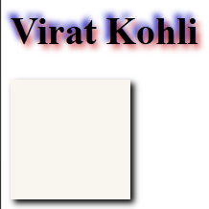

**Margin:** margins are nothing but space around an element

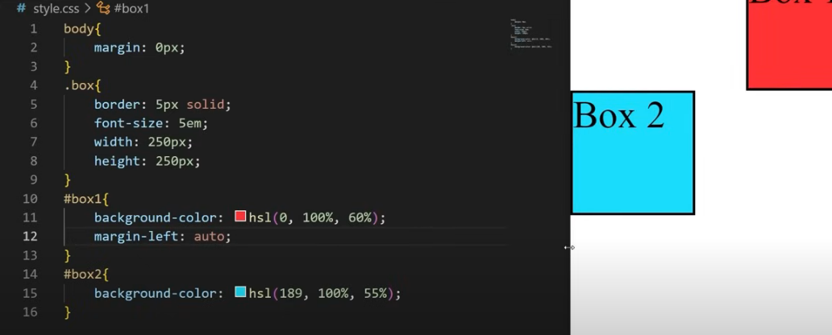

Here margin-left : auto means box will adjusted up to page ending in right side

**Float**: it will allow other elements to float around

With this property our text will be wrap around the image

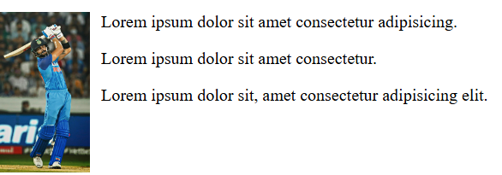

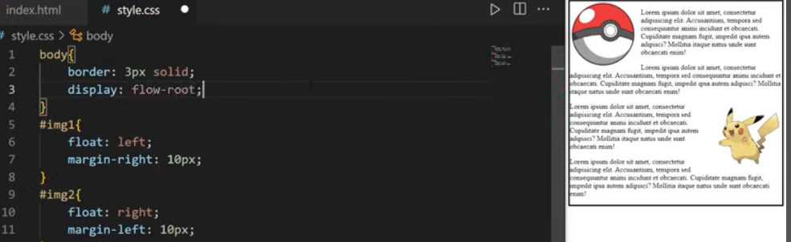

With flow-root property image will not come out from box,

**Over flow:** Property that sets the desired behaviour when content does not fit in the parent element box (overflows)

Overflow: visible

Overflow: hidden

Overflow: clip

Overflow: scroll

Overflow: auto

div{

    border: 2px solid;

    heigth: 75px;

    overflow: hidden;

}

Based on this property if any content that overflow from box is hidden.

**Display:** property that specifies if any element is displayed

Block-level = start on a new line, take up the full width available (h1,div,p,form,header,footer)

inline = do not start on a new line width is limited to what is needed (span,a,img)

for in line elements height and width properties will not apply by using display property we can utilise it.

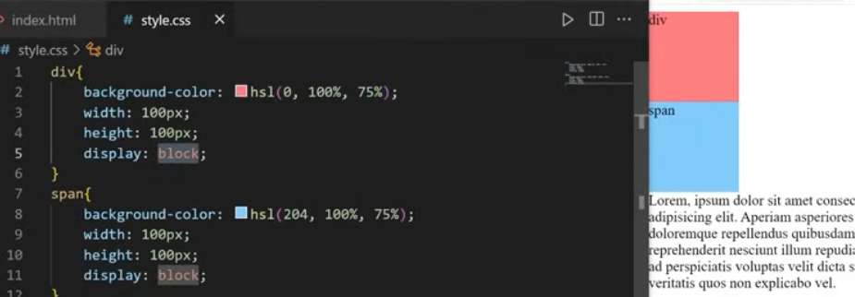

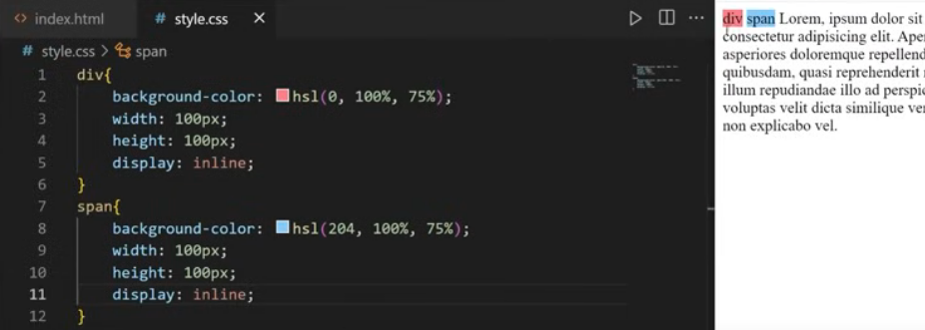

**Width and Heigth properties:**

In css height and automatically by default as auto means it will adjust automatically

If we use float property it will not applicable because of our border property with only 2px

To fix it we can use box-sizing property,

Box-sizing: border-box;

we can use above property in for all body properties using *

*{

    box-sizing: border-box;

}

.box{

    border: 2px solid;

    padding: 5px;

    width: 50%;

    float: left;

}

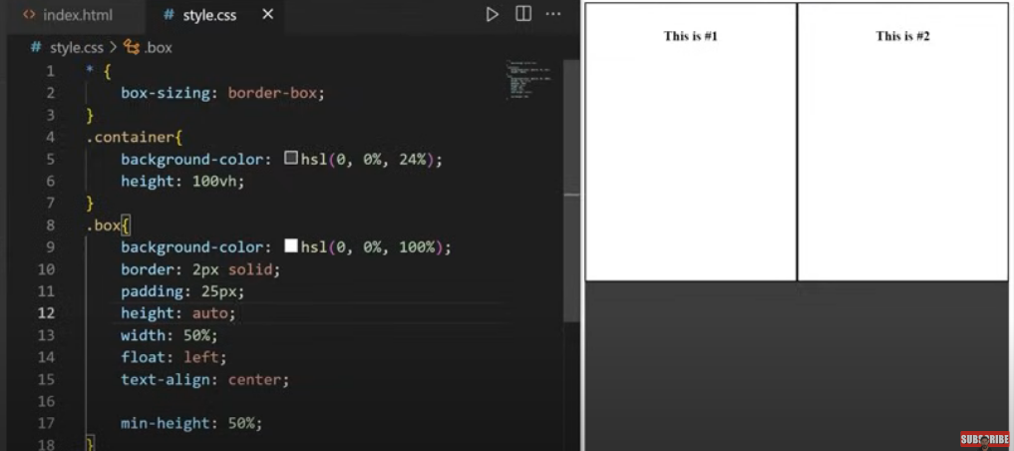

**Positions:**

Relative= positioned relative to where it normally

fixed = positioned relative to the viewport

absolute = positioned relative to nearest ancestor

sticky = positioned based on scroll position

static = default position for an element

fixed means it will not change from fixed point

for absolute even though we change box1 then box2 will also change

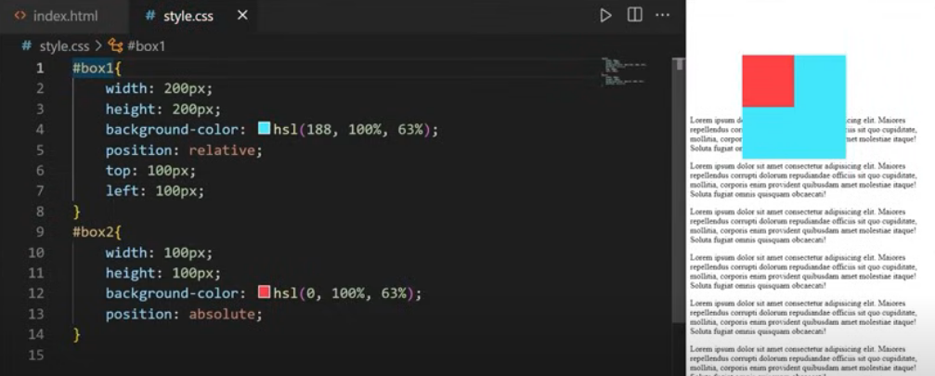

**Background images using css:**

With this property now image will take entire property

Backgound-size:cover;

body{

    background-image: url(chicagobean.jpeg);

    /* background-attachment: fixed; */

    background-size: cover;

}

With attachment we can fix image position like if we use background-position:center

Then based on attachment property image will be fixed.

**Combinators:** Explains the relationship between listed selectors

. = descendent (space)

> = child

~ = general sibling

+ = adjacent sibling

<body>

    <div id = "container">

        <p>This is #1</p>

        <p>This is #2</p>

        <div><p>This is #3</p></div>

    </div>

        <p>This is #4</p>

        <p>This is #5</p>

</body>

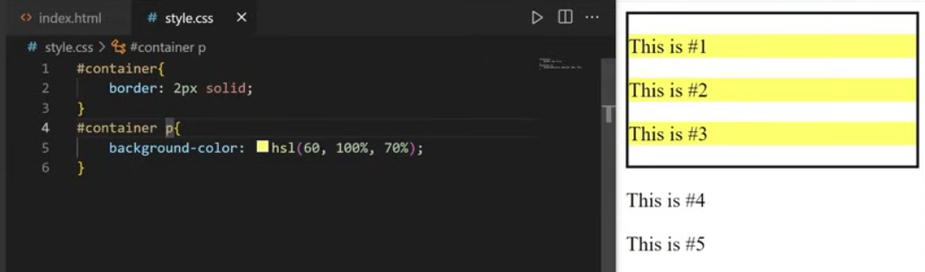

Descendent example mentioned #container p{ space applied

So highlighted only paragraphs consists in container.

Child: example mentioned #container > p{ space applied

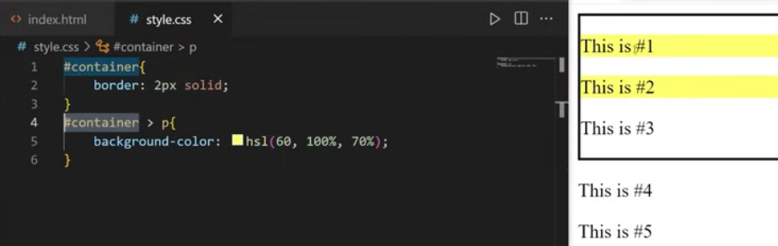

General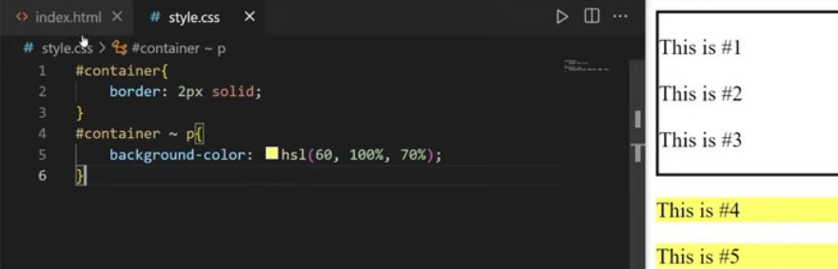

Adjacent:

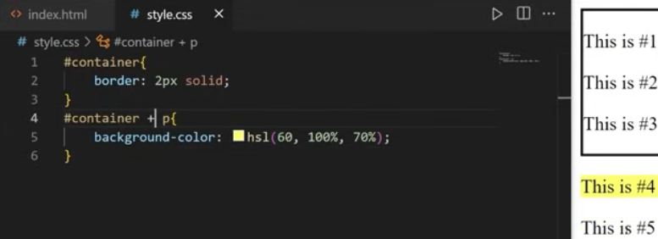

**Pseudo Classes:** I have used hyperlink for it a link is also a super class

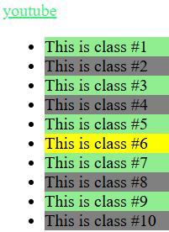 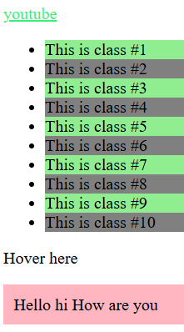 Here “Hello hi how are you” is invincible it will visible only if hovered on “hover here”(means scrolling) by hovering only we will get yellow colour

<body>

    <a href="https://www.youtube.com/">youtube</a>

    <ul>

        <li>This is class #1</li>

        <li>This is class #2</li>

        <li>This is class #3</li>

        <li>This is class #4</li>

        <li>This is class #5</li>

        <li>This is class #6</li>

        <li>This is class #7</li>

        <li>This is class #8</li>

        <li>This is class #9</li>

        <li>This is class #10</li>

    </ul>

    <div id="greeting">Hover here

        <p>Hello hi How are you</p>

    </div>

</body>

a:link{

    color: hsla(0, 92%, 58%, 0.942);

}

a:hover{

    color: #1818ad;

    font-size: 1.1em;

}

a:active{

    color: aqua;

    font-size: 1.1em;

}

a:visited{

    color: rgb(44, 239, 112);

    font-size: 1.1em;

}

li:hover{

background-color: yellow;

}

li:not(:hover){

    background-color: gray;

}

li:nth-child(odd){

    background-color: lightgreen;

}

#greeting p{

    background-color: lightpink;

    padding: 10px;

    display: none;

}

#greeting p{

    display: block;

}

**Pseudo Element:** Keyword added after a selector that’s used to style specific part of an element.

Selector : pseudo element

h1::first-letter{

    font-size: 2em;

    font-style: italic;

}

p::first-line{

    background-color: yellow;

}

p::selection{

    color: rgb(68, 146, 37);

    background-color: darkgray;

}

#fruit li::before{

    content: "✅";

}

#Apple::after{

    content: "🍎";

}

#Bannana::after{

    content: "🍌";

}

#Orange::after{

    content: "🍊";

}

#fruit li::marker{

    content: "✅";

}

<body>

    <h1>Hello Hi How are you?</h1>

    <p>Lorem ipsum dolor sit amet consectetur adipisicing elit. Qui eius animi earum perferendis voluptas commodi. Quos mollitia impedit, blanditiis, totam nam omnis cum labore cumque expedita ipsum natus magnam sint nesciunt quam.</p>

    <ul id="fruit">

        <li id ="Apple">This is Apple</li>

        <li id ="Bannana">This is Bannana</li>

        <li id ="Orange">This is Orange</li>

    </ul>

</body>

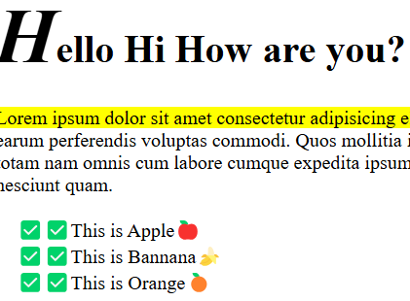

**Pagination:** It is a method by which a document is separated into pages and numbers are given

.pagination{

    text-align: center;

}

.pagination a{

    color: black;

     text-decoration: none; /*removed underlines */

     padding: 8px 15px;

     display: inline-block;

}

.pagination a.active{

    background-color: hsl(120, 87%, 76%);

    font-weight: bold;

    border-radius: 5px;

}

.pagination a:hover:not(.active){

    color: hsl(125, 72%, 43%);

    border-radius: 5px;

}

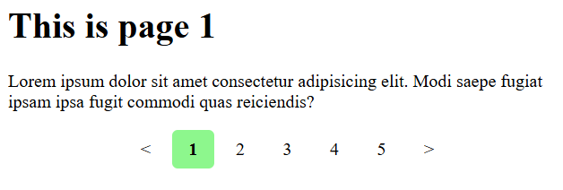

**Dropdown Menus:**

.dropdown{

    display: inline-block;

}

.dropdown button{

    background-color: rgba(4, 15, 19, 0.608);

    color: aqua;

    padding: 10px,15px;

    border: none;

    cursor: pointer; /*when we hover cursor changes to pointer*/

}

.dropdown a{

    display: block;

    color: black;

    text-decoration: none;

    padding: 10px 15px;

}

.dropdown .content{

    display: none;

    position:absolute;

    background-color: hsl(0, 0%, 95%);

    min-width: 100px;

    box-shadow: 2px 2px 5px hsla(0, 0%, 0%,0.0);

}

.dropdown:hover .content{

    display: block;

}

.dropdown:hover button{

    background-color: rgb(9, 202, 28);

}

.dropdown a:hover {

    background-color: hsl(0, 0%, 80%);

}

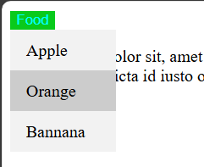

**Navigation Bar :**

body{

    margin: 0px;

}

main{

    margin: 20px;

}

h1{

    text-align: center;

}

.navbar ul{

    list-style-type: none;

    background-color: hsl(0, 0%, 90%);

    padding: 0px;

    margin: 0px;

    overflow: hidden;

}

.navbar a{

    color: rgb(15, 16, 15);

    text-decoration: none;

    padding: 15px;

    display: block;

    text-align: center;

}

.navbar a:hover{

    background-color:  hsl(0, 0%, 80%);

}

.navbar li{

    float:  left;

}

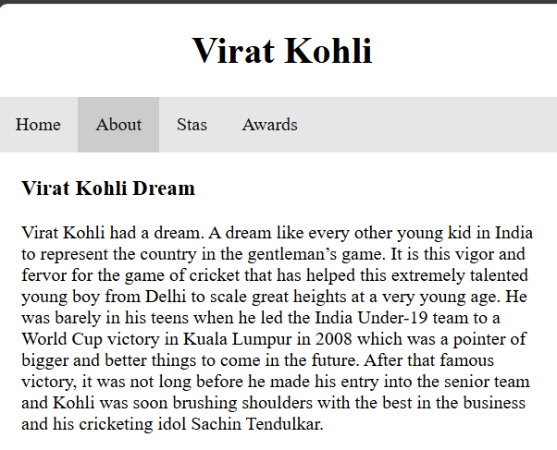 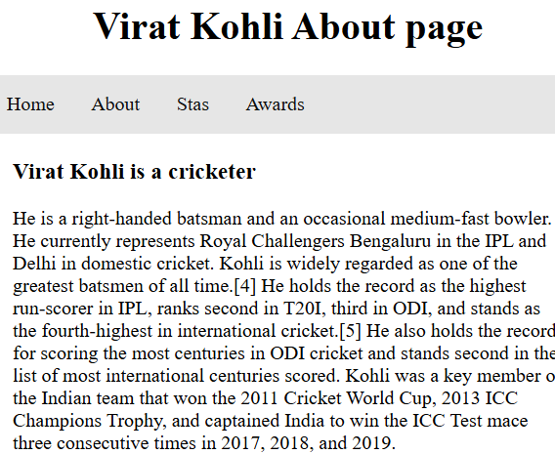

**Basic webpagelayout:**

**Semantic tags:** keep your content originized better for seo assists screen readers and other tech for accessibility.

Header: introductory content

Nav> = navigation bar, links

Main> main content(section,aside,article,div)

Section= dependent content

Aside=side content

Article=independent content

Footer= closing content

<body>

    <header>

        <h2>Header</h2>

    </header>

    <nav class="navbar"></nav>

    <main>

        <aside>

            <h2>This is a aside</h2>

            <p>Lorem ipsum dolor, sit amet consectetur adipisicing elit. Beatae dolorum autem cum ipsa, consequatur mollitia quaerat aperiam dolores?</p>

        </aside>

        <section>

            <h2>This is a section</h2>

            <p>Lorem ipsum dolor sit, amet consectetur adipisicing elit. Deleniti inventore dicta officia!</p>

            <p>Lorem ipsum dolor sit amet consectetur adipisicing elit. Modi, quaerat minima.</p>

        </section>

        <article>

            <h2>This is a article</h2>

            <p>Lorem ipsum, dolor sit amet consectetur adipisicing elit. Delectus incidunt illo perspiciatis veniam.</p>

            <p>Lorem ipsum dolor sit amet consectetur adipisicing elit. Accusamus porro sunt ad et adipisci!</p>

        </article>

    </main>

    <footer>

        <h2>Styling Footer</h2>

    </footer>

</body>

*{

    box-sizing: border-box;

}

body{

    margin: 0px;

}

header{

    background-color: hsl(0, 0%, 87%);

    text-align: center;

    padding: 10px;

}

.navbar{

    background-color: hsl(0, 1%, 17%);

    height: 50px;

}

aside{

    width: 20%; /*it will take only 20% space in web page*/

    float:left;

    padding: 10px;

}

section{

    width: 40%;

    float:left;

    padding: 10px;

}

article{

    width: 40%;

    float:left;

    padding:10px;

}

footer{

    display: block;

    clear: both;/*for clearing float*/

    background-color: hsl(0, 0%, 87%);

    text-align: center;

    padding: 10px;

}

@media screen and (max-width:600px){

    aside,section,article{

        width:100%

    }

}

if a user is on a mobile device and or the width is 600 pixels or below then we'll switch to a mobile version of the web page each of these elements are a side section and article elements are taking up 100 of the width available then if we were to expand this web page or we're viewing on a desktop we switch to the desktop version this is also known as responsive CSS.   
It is for  media-screen and nax-width property.

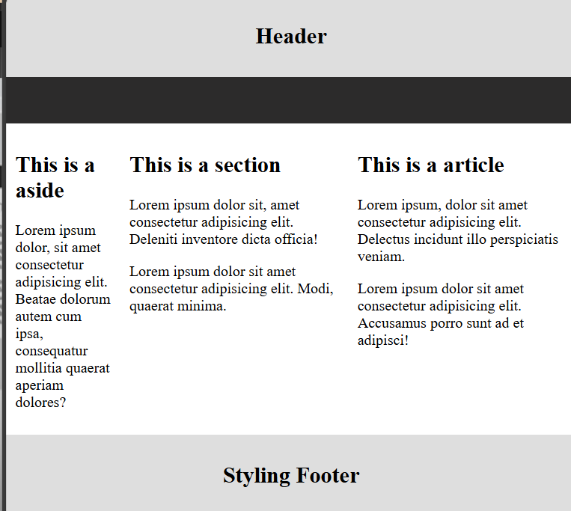

**Image Gallery:**

<body>

    <div class="gallery">

        <a target="_blank" href="images/CJT47.jpg">

            <img src="images/CJT47.jpg" alt="nature" width="200">

        </a>

        <div class="description">natures</div>

    </div>

    <div class="gallery">

        <a target="_blank" href="images/zMoo4.jpg">

            <img src="images/zMoo4.jpg" alt="rabbit" width="200">

        </a>

        <div class="description">rabbits</div>

    </div>

    <div class="gallery">

        <a target="_blank" href="images/hOIuY.jpg">

            <img src="images/hOIuY.jpg" alt="animal" width="200">

        </a>

        <div class="description">animals</div>

    </div>

</body>

.gallery{

    display: inline-block;

    border: 1px solid hsl(0, 0%, 60%);

    margin: 5px;

    width: 200px;

}

.gallery .description{

    padding: 10px;

    text-align: center;

}

.gallery:hover{

    border: 1px solid hsl(0, 0%, 20%);

}

.gallery img{

    width: 100%;

    height: auto;

}

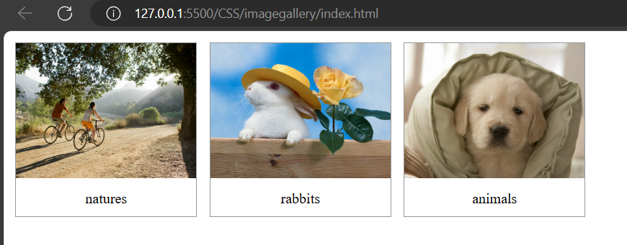

**Icons:**

Use this website for font-size icons in css fontawesome.com

<body>

    <div class="icons"></div>

    <a href="">

        <i class="fa-sharp fa-solid fa-house"></i>

    </a>

    <a href="https://x.com/">

        <i class="fa-brands fa-twitter"></i>

    </a>

    <a href="https://www.youtube.com/">

        <i class="fa-brands fa-youtube"></i><!-- /*we cn add font size also as fa-5x like wise-->

    </a>

    <a href="https://www.instagram.com/">

        <i class="fa-brands fa-instagram"></i>

    </a>

</body>

.icons{

    text-align: right;

}

.icons a{

    text-decoration:none;

}

.fa-sharp.fa-solid.fa-house{

    color: hsl(0, 2%, 38%);

}

.fa-sharp.fa-solid.fa-house:hover{

    color: hsl(0, 2%, 48%);

}

.fa-brands.fa-twitter{

    color: hsl(197, 84%, 53%);

}

.fa-brands.fa-twitter:hover{

    color: hsl(197, 84%, 63%);

}

.fa-brands.fa-youtube{

    color: hsl(0, 100%, 50%);

}

.fa-brands.fa-youtube:hover{

    color: hsl(0, 100%, 60%);

}

.fa-brands.fa-instagram{

    color: hsl(0, 46%, 48%);

}

.fa-brands.fa-instagram:hover{

    color: hsl(0, 46%, 58%);

}



**Flex Properties:**

<body>

    <div class="container">

        <div class="box" id="box1">1</div>

        <div class="box" id="box2">2</div>

        <div class="box" id="box3">3</div>

        <div class="box" id="box4">4</div>

        <div class="box" id="box5">5</div>

        <div class="box" id="box6">6</div>

        <div class="box" id="box7">7</div>

        <div class="box" id="box8">8</div>

    </div>

</body>

.container{

    display: flex;

    border: 10px solid black;

    height: 90vh;

    align-items: flex-end;/*placing elements at bottom, baseline property at above*/

    justify-content: space-between; /* space will be equally distributed */

    flex-wrap: wrap;/*it will wrap up according to space*/

    align-content: flex-start;/*space between rows will be removed*/

    column-gap: 3em;

    row-gap: 3em;

}

.box{

    width: 150px;

    height: 150px;

    font-size: 8em;

    text-align: center;

    border-radius: 15px;

}

#box1{

    background-color: hsl(0, 100%, 70%);

    align-self: start;/*allign property will start from here*/

}

#box2{

    background-color: hsl(52, 100%, 70%);

}

#box3{

    background-color: hsl(111, 100%, 70%);

}

#box4{

    background-color: hsl(201, 100%, 70%);

}

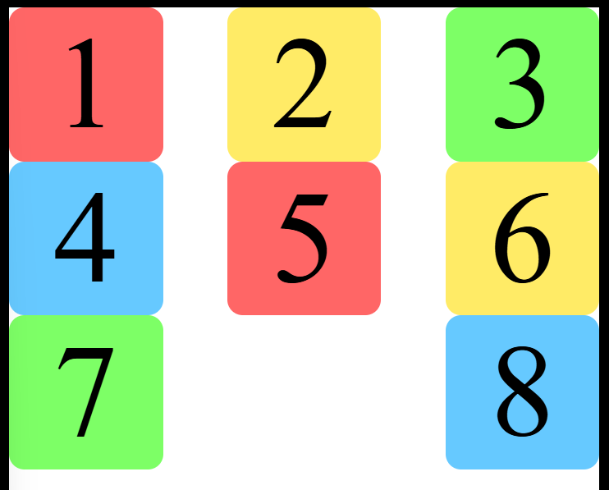

**Transformations:** it is a css property which lets you rotate scale,skew or transulate an element

<body>

    <div id="Box1">hello</div>

    <div class="Box2">Virat</div>

    <div class="Box3">Chaitu</div>

    <img src="chicago.jpg" alt="">

</body>

body{

    margin: 0;

}

#Box1{

    width: 500px;

    height: 250px;

    border: 5px solid;

    font-size: 13em;

    text-align: center;

    background-color: hsl(120, 100%, 70%);

    transform: translateX(50px);/*this box will be moved to 50px from x axis*/

    /* we can transulate it in y axis also  using transulatey*/

    transform: translate(50px,50px);

    transform: rotate(180deg);

    transform: scaleX(2);/* 2 means 200%*/

    transform: skew(45deg);

    /* we can use all in one transform property */

    /* transform: translateX(100%) rotateZ('90deg') scale(0.5); */

}

.Box2{

    width: 500px;

    height: 250px;

    border: 5px solid;

    font-size: 13em;

    text-align: center;

    background-color: hsl(203, 100%, 70%);

    transform: translate(50px,50px);

    transform: rotate(180deg);

    transform: scaleX(2);

    transform: skew(45deg);

}

.Box3{

    width: 500px;

    height: 250px;

    border: 5px solid;

    font-size: 11em;

    text-align: center;

    background-color: hsl(78, 100%, 70%);

    transform: translate(50px,50px);

    transform: rotate(180deg);

    transform: scaleX(2);

    transform: skew(45deg);

}

img{

    transform: translateX(100%) rotateZ(180deg) scaleX(4);

}

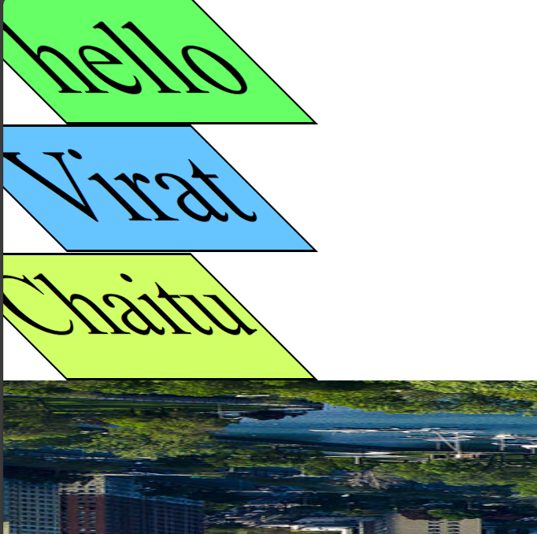

**Animations:**

<!DOCTYPE html>

<html lang="en">

<head>

    <meta charset="UTF-8">

    <meta name="viewport" content="width=device-width, initial-scale=1.0">

    <title>Animations</title>

    <link rel="stylesheet" href="style.css">

</head>

<body>

    <div id="Box">Hi</div>

    <img src="animationimage.jpg" alt="">

</body>

</html>

body{

    background-color: hsl(0, 0%, 0%);

}

#Box{

    width: 250px;

    height: 250px;

    background-color: hsl(0, 100%, 50%);

    font-size: 13em;

    text-align: center;

    animation-name: slideLeft;

    animation-duration: 2s;

    animation-iteration-count: 2;/*to occur animation more than 1 time(2 times because we used 2)

    we will use iteration property, we can also use infinite*/

    animation-direction: alternate-reverse;/* we can set direction as normal(left direction),reverse(right direction),alternate(right direction00)*/

    animation-play-state: running;/*animation will be paused, running*/

    animation-timing-function:ease-in-out;/*speeds up nd slows down before reaches destionation*/

    /*we can also use linear to maintain consistency speed*/

    /*we can use steps function also to pause animation in steps */

}

img{

    animation-name: slideUp;

    animation-duration: 2s;

    animation-iteration-count: 2;animation-direction: alternate-reverse;/* we can set direction as normal(left direction),reverse(right direction),alternate(right direction00)*/

    animation-play-state: running;

    animation-timing-function:ease-in-out;

}

/* I want to see shadow animation when i hover my box */

/* #box:hover{

    animation-name: glow;

    animation-duration: 2s;

} */

@keyframes slideLeft{

    from{transform: translateX(100px)}

}

@keyframes slideRight{

    to{transform: translateX(300%)}

}

@keyframes slideUp{

    from{transform: translateY(300%)}

}

@keyframes slideDown{

    to{transform: translateY(300%)}

}

@keyframes rotate{

    100%{transform: rotateX(360deg)}

}

@keyframes rotate{

    100%{transform: rotateZ(360deg)}

}

@keyframes grow{

    100%{transform: scale(2,2);}

}

@keyframes shrink{

    100%{transform: scale(0.5,0.5);}

}

@keyframes fade{

    100%{opacity: 1}

}

@keyframes colorChange{

    0%{background-color: hsl(0, 100%, 50%)}

    20%{background-color: hsl(39, 100%, 50%)}

    40%{background-color: hsl(60, 100%, 50%)}

    60%{background-color: hsl(103, 100%, 50%)}

    80%{background-color: hsl(201, 100%, 50%)}

    100%{background-color: hsl(268, 100%, 50%)}

}

@keyframes glow{

    50%{box-shadow: 0px 0px 50px hsl(60, 100%, 50%)}

}

